NAME: SHYAM GANESH . S
DEPARTMENT: B.E BIOMEDICAL ENGINEERING
COLLEGE: 8151- DHANALAKSHMI SRINIVASAN INSTITUTE OF TECHNOLOGY, SAMAYAPURAM, TRICHY
NAANMUDHALVAN COURSE: DIGITAL MARKETING
NM ID: 346C86029313A5AA4AC4D7EB30D8213B
NM TEAM ID: NM2023TMID02386

ASSIGNMENTS ON DIGITAL MARKETING
1. Create a Blog or Website using Blogspot and Wordpress. Customize the theme design and post new articlre with 500 words.
Wordpress URL:
https://lamourew.wordpress.com/2023/10/19/celebrate-in-style-with-lamour-your-go-to-event-management-brand/


2.Create a New Facebook Business Page and Post One Social Media Poster for your brand.
https://www.facebook.com/lamoureew
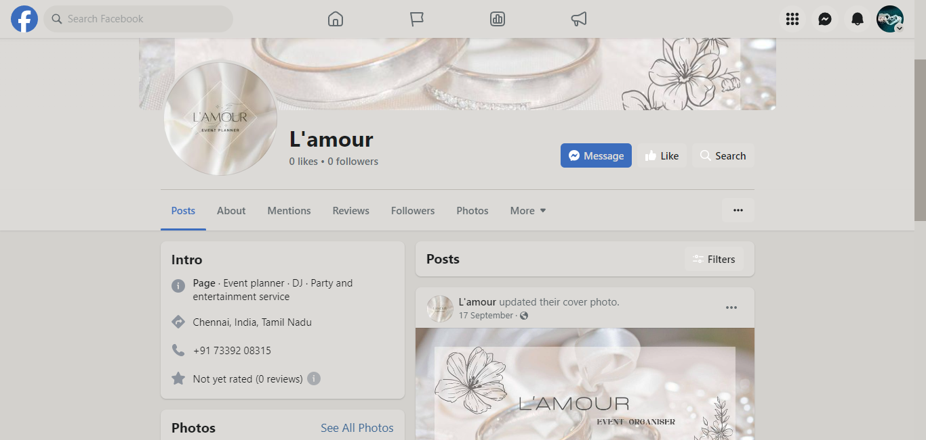

3.Create and design a social media advertisement poster using canva.


4. Create email news letter design using Canva or mail chimp.
